Module 5 Activity

Michael Rothbauer

Rasmussen College

Author Note

This paper is being submitted on December 9th, 2018, for Michael Rothbauer’s Advanced Mobile Web Applications.

Module 5 Activity

Data modeling is a very important aspect of software development. It is important because it can help determine how the data is used, stored, and retrieved. Depending on the scenario, the methods or models may be different. They can also be used in a variety of purposes depending on the specific needs of the data. Three types that to review include Web SQL Databases, Indexed Databases, and File Access.

Web SQL Databases can be a very helpful tool in web development. The primary reason is that it uses an API to store data rather than using cookies. This allows for data to be easily and quickly used without requiring additional computing power. The use of cookies on the other hand does require additional computing power because cookie data is transmitted with every request.

To function, Web SQL utilizes three different interfaces: Storage, Window, and Storage Event. The storage interface object allows access to key and value pairs (WHATWG, 2018). This allows for data to be set, retrieved, or deleted. The window interface is responsible for providing access to the local objects and session itself. A storage event occurs when the storage area changes and an event become executed upon an object.

*Web SQL uses a data model that is very similar to that of SQLite*.

Example:

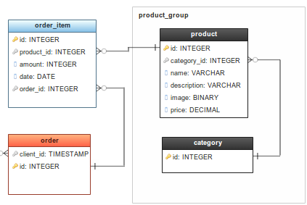

Indexed perform very similarly to Web SQL as it uses the same three primary interfaces, but a little bit differently. Web Storage itself isn’t necessarily useful for storing large amounts of data especially structured data. Indexed databases provide a solution and runs more as a transactional database. Indexed databases allow retrieval of objects that are indexed with a key (Mahemoff, 2010). Doing so will improve query performance and the amount of data that can be stored effectively.

*What a common indexed database model would resemble.*

Example:

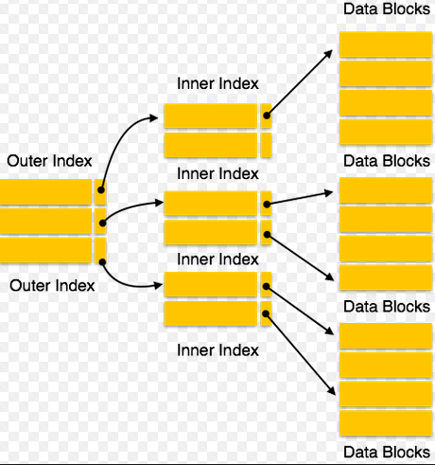

File Access is another web storage method that can be used to improve performance. This type of storage stands apart from the other two because File Access utilizes very powerful APIs to interact with a user’s local file system (Mahemoff, 2010). This gives web applications the possibilities to asynchronously read files. In addition, it may also write files to a temporary location, read a file directory, create blogs, and upload binary data. This is more suitable for large content such as images, audio, and video. File access, as of now, most similarly uses the ERD model that Web SQL utilizes. The DB transactions are handled by utilizing JSON.

All three of these methods can be used very differently in applications and oriented towards their specific needs. Each can be utilized for their benefits. For example, Web SQL can be utilized because of its generally good performance, it is robust, and easy to maintain. Unfortunately, Web SQL is deprecated because it operates to similarly to that of SQLite and points to a third-party service. For this reason, it wasn’t accepted very widely. Indexed DBs are great because data can be indexed according to search keys. Database interaction also will not slow or lock the user interface. However, the API of indexed DBs can be very complex. Lastly,

File Access benefits include the amount of large content and deliver excellent performance. Now, there is no built-in indexing support for File Access.

In conclusion, I think that any of the systems can be used based around an application specific need. If performance is an issue it may be advisable to choose Indexed Databases or File Access. If values need to be stored, easily accessible, and easy to maintain then it may be advisable to utilize Web SQL. All in all, it depends on the very specific needs of the application.

# References

Mahemoff, M. (2010, October 1). *Client Side Storage*. Retrieved from HTML 5 Rocks: https://www.html5rocks.com/en/tutorials/offline/storage/

WHATWG. (2018). *HTML Living Standard*. Retrieved from WhatWG (Apple, Google, Mozilla, Microsoft): https://html.spec.whatwg.org/multipage/webstorage.html#the-storage-interface